**EVENT ENTRY FORM: Mangakino 30th Nov -1st Dec 2024**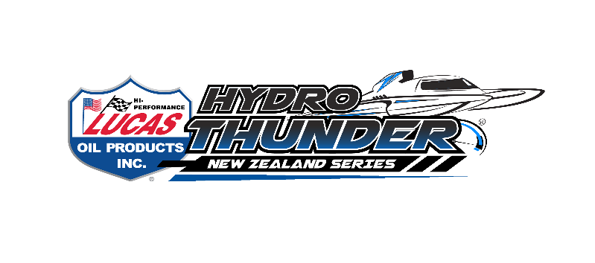

*Hydro Thunder Regatta Entry*

Grand Prix Hydroplanes (Invoiced separately)

Standard entry $200 ____________

16 years and under FREE ____________

Featuring: TOTAL TRANSPORT JUNIOR SERIES

HYDRO THUNDER NZ CHAMPIONSHIP SERIES R1

NORTH ISLAND GRAND PRIX ______

NORTH ISLAND FORMULA 1 _______

NORTH ISLAND MODIFIED HYDROPLANE _______

***RACING BOTH DAYS FOR ALL CLASSES***

**COMPETITOR INFORMATION AND RACE PROGRAM TO FOLLOW**

Entries can be by Post or email

Internet bank: to BNZ 02-0100- 0713382- 00 (please use your name as reference)

NZGP Hydroplane Drivers Club

PO Box 132-16 ,Onehunga, Auckland 1643 Email : [denise@accelerationonwater.co.nz](mailto:denise@accelerationonwater.co.nz)

**BOAT NAME ……………………………………**

**CLASS ……………………………………**

**DRIVERS NAME ……………………………………**

**ADDRESS ……………………………………**

**Email Address ……………………………………**

**PHONE NUMBER ……………………………………**

*The NZGPHDC reserves the right to alter the program due to unforeseen circumstances*