EVENT ENTRY FORM: Mangakino 1-2ND NOVEMBER 2025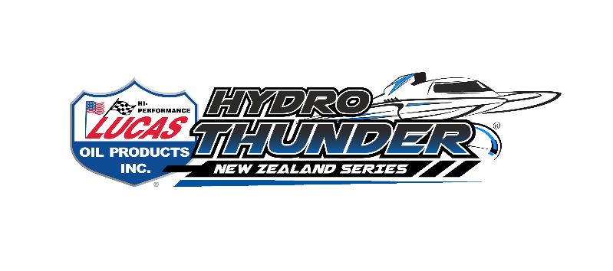
Hydro Thunder Regatta Entry
Grand Prix Hydroplanes Lucas Oil Hydro Thunder (R1)(invoiced separately)
Friday 31st October (Test Day) $150 __________
(to cover the cost of the medics and cranes)
Standard entry $200 ___________
16 years and under FREE ___________
Featuring: TOTAL TRANSPORT JUNIOR SERIES
NORTH ISLAND UU _______
NORTH ISLAND FORMULA ONE _______
RACING BOTH DAYS FOR ALL CLASSES
COMPETITOR INFORMATION AND RACE PROGRAM TO FOLLOW
Entries can be by Post or email
Internet bank: to BNZ 02-0100- 0713382- 00 (please use your name as reference)
NZGP Hydroplane Drivers Club Box 132-16 ,Onehunga, Auckland 1643 Email : denise@accelerationonwater.co.nz
BOAT NAME ……………………………………
CLASS ……………………………………
DRIVERS NAME ……………………………………
ADDRESS ……………………………………
Email Address ……………………………………
PHONE NUMBER ……………………………………
The NZGPHDC reserves the right to alter the program due to unforeseen circumstances

