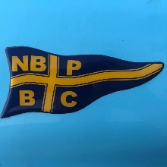

Lucas Oil Hydro Thunder Round 3
Regatta Entry Form for 10-11th January 2026
Lake Ruataniwha, Twizel

Boat Name ……………………………………Class………………………………

Driver…………………………………………..Boat No……………………………

Club……………………………………………License No………………………..

Phone…………………………………………Email……………………………….

Regatta Entry Fee $150…………………………………………………………….

Total Transport Junior Series (FREE ENTRY)____________________

South Island Championships: (Please indicate if you are entering below at no extra cost)

Grand Prix ____B.A.D_____Mod H________

- All South Island Championships to be contested over (2) HEATS.
- AE Baker Australasian Hydroplane Championship
- South Island entries close: 1st January you will be notified if not enough entries received to run your South Island title.
- Racing for all classes over the two days.

Email your entry to: denise@accelerationonwater.co.nz

Direct credit you entry fee to, NZGP Hydroplane Drivers Club:
Bank account no - BNZ: 02- 0100-0713382-00
Please use you name as reference.

