
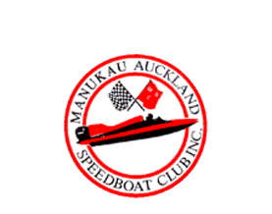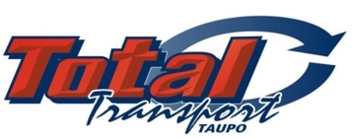
Lucas Oil Hydro Thunder Official Entry Form
Lake Karapiro 7-8th February 2026
Feature Events:
- Lucas Oil Hydro Thunder NZ Series
- Matt Morrison Memorial Trophy
- 101st Masport Cup - Total Transport Junior Series
- Marsh Motor Sport Trophy - Dennis Taylor Memorial
- NZ Formula One Series - Moult Gold Cup

Standard entry Fee : $200 ___ 16 years & under FREE___ Crane Fee : $100 ___ Total ______
BOAT NAME __________________________________
CLASS __________________________________
DRIVERS NAME __________________________________
EMAIL ADRESS __________________________________
PHONE NUMBER ___________________________________
Please email your entry to : denise@accelerationonwater.co.nz or Post to PO Box 132-16 Onehunga Auckland 1643.
Internet banking to NZGP Hydroplane Drivers Club: BNZ 02-0100-0713382-000
Please use your name as reference. ENTRIES CLOSE 31st January 2026


